Part 1: Conceptual Understanding
1. Difference between image classification and object detection: Image classification answers the question "What is in this image?" by assigning a single label (like "dog" or "car") to the entire picture. Object detection takes it a step further by answering "What is in this image and where is it?" It not only classifies multiple objects within the same image but also localizes them by drawing bounding boxes around their exact positions.
2. Why we use fractions for bounding box coordinates: Using fractions (normalized coordinates from 0 to 1) makes the bounding box independent of the image's absolute pixel dimensions. If we need to resize the image to feed it into a model (e.g., from 1024x768 down to 300x300), the fractional coordinates will still point to the correct relative location without needing complex recalculations.
3. What IoU measures and why 0.5 is a common threshold: Intersection over Union (IoU) measures the overlap between the model's predicted bounding box and the actual ground truth bounding box. It is calculated by dividing the area of overlap by the total combined area of both boxes. An IoU of 0.5 is commonly used because it indicates a "good enough" match—meaning at least 50% of the box area is shared. This allows for slight human error in drawing the ground truth boxes while still confirming the model found the core object.

Part 2: Implementation Experience
(Feel free to adjust these to match exactly what you experienced!)
1. Most challenging part of the visualization functions: The most challenging part was correctly scaling the fractional coordinates back into exact pixel values for Matplotlib to draw the rectangle. I solved it by carefully reviewing the formulas and ensuring I multiplied xmin and width by img_width, and ymin and height by img_height.
2. Walkthrough of IoU implementation and the max(0, ...) rule: To calculate IoU, I first found the coordinates of the overlapping inner rectangle by taking the maximum of the top-left coordinates and the minimum of the bottom-right coordinates. If I forgot to use max(0, ...) for the intersection width and height: When two boxes do not overlap at all, the calculated intersection width or height would be negative. Multiplying two negative numbers would yield a positive area, completely breaking the math and falsely telling the system that non-overlapping boxes have a valid intersection.
3. Debugging: (Example answer): I encountered an error when trying to plot the boxes because I forgot to cast the class indices to integers, which caused an IndexError when looking up the label in class_names. I fixed it by wrapping the class ID extraction in int().

Part 3: Results Analysis

1. Confidence threshold experiment:
- Observations: With a low threshold of 0.3, the model drew significantly more bounding boxes, but many of them were incorrect (false positives) or duplicate boxes around the same object. With a high threshold of 0.7, there were very few boxes, but the ones shown were highly accurate.
- Which is better: A threshold closer to 0.5 or 0.7 is generally better for visual clarity, as 0.3 creates too much noise and clutters the image with unsure guesses.
2. IoU threshold experiment:
- Observations: When changing the IoU threshold from lenient (0.3) to strict (0.7), the Recall and Precision both drop.
- Why this happened: A strict IoU threshold means the model's bounding box has to align almost perfectly with the human-drawn box to be considered a "True Positive". Because the model's boxes are slightly off-center or differently sized, they get penalized and counted as False Positives, lowering the overall score.
3. Model errors:
False Positive The model detected a horse and a person and confidently labeled it as a "bicycle" and "tvmonitor."
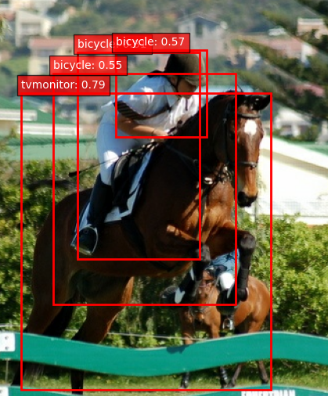
- False Negative: The model completely missed a small bush because it was too smal
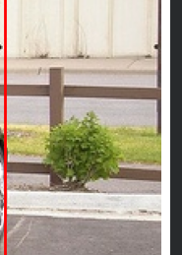

Part 4: Critical Thinking
1. Precision vs Recall trade-off:
- Self-driving car (pedestrians): I would prioritize high recall. It is far safer for the car to occasionally trigger a false alarm (e.g., braking for a shadow it thought was a person) than to miss an actual pedestrian (a false negative), which could be fatal.
- Photo app (tagging objects): I would prioritize high precision. Users want their photos organized accurately. Missing a few objects (lower recall) is fine, but incorrectly tagging a dog as a cat (false positive) makes the app look bad and annoys the user.
2. Pre-trained models:
- Advantages: They save massive amounts of time and computational resources. Because they are already trained on millions of images, they feature excellent feature extraction right out of the box and can be deployed quickly.
- Disadvantages: They might struggle with highly specialized or niche domains (like medical X-rays or specific manufacturing defects) without extensive fine-tuning. You are also locked into the architecture the original creators chose.
3. Real-world applications of Object Detection:
- Autonomous Vehicles: Simply classifying that a "pedestrian" is in the camera feed isn't enough; the car needs to know exactly where the pedestrian is (localization) to avoid hitting them.
- Automated Retail (e.g., Amazon Go): The store cameras must track exactly where a customer's hand is and which specific item they picked up off a shelf, requiring precise spatial tracking.
- Security and Surveillance: A security system needs to isolate the specific location of an intruder in a frame to track their movement across a property or zoom in on their face.

